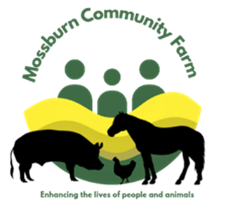
Privacy & Cookie Policy

Privacy Policy

This Privacy Policy governs the manner in which Mossburn Community Farm collects, uses, maintains and discloses information collected from users.

Personal identification information
We may collect personal identification information from Users in a variety of ways, including, but not limited to, when Users visit our site, register on the site, place an order, subscribe to the newsletter, fill out a form, and in connection with other activities, services, features or resources we make available on our Site. Users may be asked for, as appropriate, name, email address, mailing address, phone number, credit card information. Users may, however, visit our Site anonymously. We will collect personal identification information from Users only if they voluntarily submit such information to us. Users can always refuse to supply personally identification information, except that it may prevent them from engaging in certain Site related activities.

Non-personal identification information
We may collect non-personal identification information about Users whenever they interact with our Site. Non-personal identification information may include the browser name, the type of computer and technical information about Users means of connection to our Site, such as the operating system and the Internet service providers utilized and other similar information.

Web browser cookies
Our Site may use “cookies” to enhance User experience. User’s web browser places cookies on their hard drive for record-keeping purposes and sometimes to track information about them. In general, cookies are used to retain user preferences, store information for things like shopping carts, and provide anonymised tracking data to third party applications like Google Analytics. Users may choose to set their web browser to refuse cookies, or to alert you when cookies are being sent. Please note that some parts of the Site may not function properly with cookies disabled.

How we use collected information
Mossburn Community Farm may collect and use Users personal information for the following purposes:
- To process payments
We may use the information Users provide about themselves when placing an order only to provide service to that order. We do not share this information with outside parties. We do not store any credit card details on this website.
- To improve customer service
Information you provide helps us respond to your customer service requests and support needs more efficiently.
- To personalize user experience
We may use information in the aggregate to understand how our Users as a group use the services and resources provided on our Site.

How we protect your information
We adopt appropriate data collection, storage and processing practices and security measures to protect against unauthorized access, alteration, disclosure or destruction of your personal information, username, password, transaction information and data stored on our Site. All credit and debit card information is handled by WorldPay, we do not keep any credit or debit card information on this website.

Sharing your personal information
We do not sell, trade, or rent Users personal identification information to others. We may share generic aggregated demographic information not linked to any personal identification information regarding visitors and users with our business partners, trusted affiliates and advertisers for the purposes outlined above.

Changes to this privacy policy
Mossburn Community Farm has the discretion to update this privacy policy at any time. When we do, we will revise the updated date at the bottom of this page. We encourage Users to frequently check this page for any changes to stay informed about how we are helping to protect the personal information we collect. You acknowledge and agree that it is your responsibility to review this privacy policy periodically and become aware of modifications.

Your acceptance of these terms
By using this Site, you signify your acceptance of this policy. If you do not agree to this policy, please do not use our Site. Your continued use of the Site following the posting of changes to this policy will be deemed your acceptance of those changes.

Contacting us
If you have any questions about this Privacy Policy, the practices of this site, or your dealings with this site, please contact us at:
Mossburn Community Farm, Hightae, Lockerbie, DG1 1LE.

